CREATE DATABASE SALESDB;
USE SALESDB;
CREATE TABLE Customer (
CustomerID INT PRIMARY KEY,
CustomerName VARCHAR(50) NOT NULL,
Email VARCHAR(100) NOT NULL UNIQUE,
City VARCHAR(50) NOT NULL,
Phone VARCHAR(10),
CONSTRAINT CHK_Phone
CHECK (Phone REGEXP '^[0-9]{10}$')
);
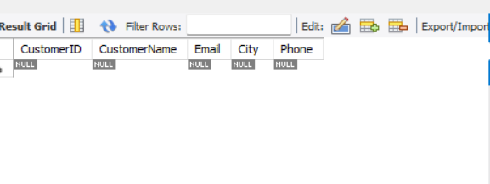
CREATE TABLE Orders (
OrderID INT PRIMARY KEY,
OrderDate DATE NOT NULL,
TotalAmount DECIMAL(10,2) CHECK (TotalAmount > 0),
PaymentStatus VARCHAR(20),
CustomerID INT,
CONSTRAINT CHK_Status CHECK (PaymentStatus IN ('Paid', 'Pending', 'Failed')),
CONSTRAINT FK_Customer_Order FOREIGN KEY (CustomerID)
REFERENCES Customer(CustomerID)
);
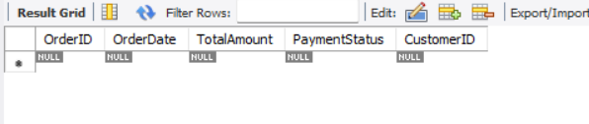
INSERT INTO Customer (CustomerID, CustomerName, Email, Phone, City)
VALUES
(1, 'Rahul ', 'rahul@gmail.com', '9876543210', 'Mumbai'),
(2, 'Anita', 'anita@gmail.com', '9876501234', 'Delhi'),
(3, 'Karan ', 'karan@gmail.com', '9123456789', 'Pune'),
(4, 'Sneha ', 'sneha@gmail.com', '9988776655', 'Chennai'),
(5, 'Amit ', 'amit@gmail.com', '9090909090', 'Ahmedabad');

SELECT * FROM CUSTOMER;

OUTPUT:
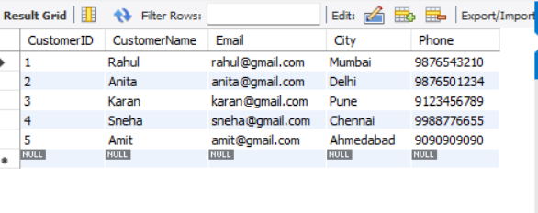

INSERT INTO Orders (OrderID, OrderDate, TotalAmount, PaymentStatus, CustomerID)
VALUES
(10, '2025-01-10', 5000.00, 'Paid', 1),
(11, '2025-01-12', 2500.00, 'Pending', 2),
(13, '2025-01-15', 3200.00, 'Paid', 1),
(14, '2025-01-18', 1500.00, 'Failed', 3),
(15, '2025-01-20', 4200.00, 'Paid', 4);

SELECT * FROM ORDERS;
OUTPUT:
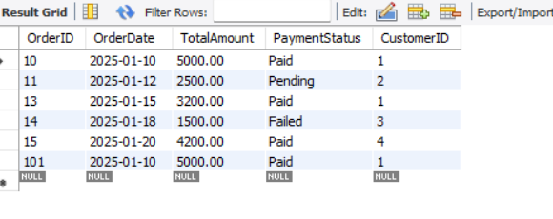
ALTER TABLE Orders
ADD PaymentMode VARCHAR(20);

ALTER TABLE Orders
ADD CONSTRAINT CHK_PaymentMode
CHECK (PaymentMode IN ('Cash', 'Card', 'UPI'));

ALTER TABLE Customer
MODIFY CustomerName VARCHAR(100);

RENAME TABLE Orders TO CustomerOrders;

OUTPUT:
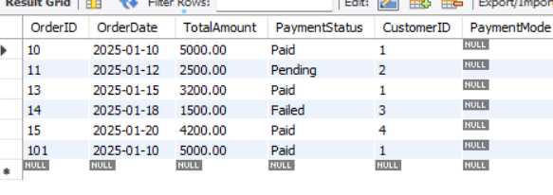

TRUNCATE TABLE CustomerOrders;
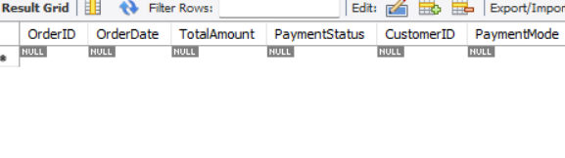
DROP TABLE CustomerOrders;
DROP TABLE Customer;

